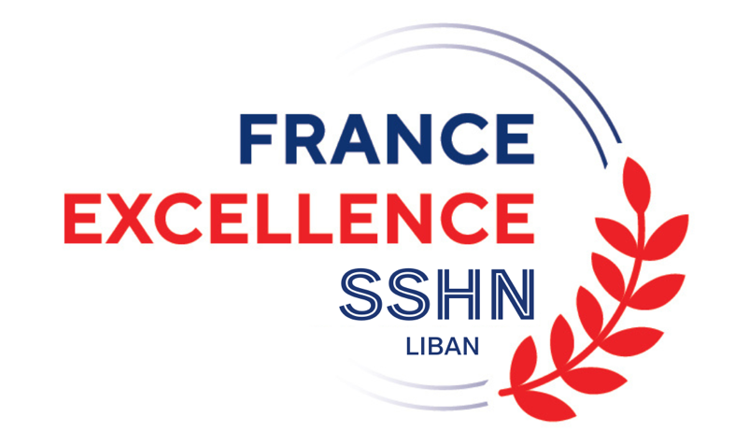

Call for applications 2024
High Level Scientific Stay Grants (SSHN)

The French Embassy in Lebanon/French Institute in Lebanon launched in 2017 the High Level Scientific Stays program to support the mobility of Lebanese researchers to initiate or strengthen high-level scientific cooperation projects between France and Lebanon.
These stays of 1 to 6 months maximum in France are aimed at doctoral students, post-doctoral students, young researchers and experienced Lebanese researchers. The deadline to submit the file is January 10, 2024.
All scholarship holders will benefit from the status of “France Excellence” scholarship holder (formerly “Boursier du Gouvernement français”).

Data processing
Unless the candidate objects, the French Embassy reserves the right to publish on its website the name, first name, original and host establishment and project of the candidates selected for a scholarship.

High-level scientific stay scholarships (1 to 6 months maximum)

1- Beneficiaries

High-level scientific stay grants are awarded to beneficiaries (doctoral students, post-doctoral students or researchers) participating in a high-level scientific and technical research and exchange program.
These grants must make it possible to initiate a research project or strengthen an existing scientific collaboration with a French research team attached to a higher education and research establishment, or a research organization or a company.

All scientific disciplines are concerned. Priority will be given to subjects of major interest for Lebanon and for the partner establishment, corresponding to the priorities set within the framework of Franco-Lebanese cooperation, to research integrated into a Franco-Lebanese research project or as a result of a project of the Hubert Curien CEDRE Program.

People who have previously benefited from this program are not given priority.
2- Duration of stay

High-level scientific stay grants are awarded:
- For a minimum duration of 1 month and up to 3 months maximum (possible extension up to 6 months, upon duly justified request) to doctoral students, post-doctoral students and researchers who obtained their PhD 5 years ago or less on the date arrival of the scholarship holder in France.
- For a minimum duration of 15 days and up to 1 month maximum (possible extension of up to 3 months, upon duly justified request) to post-doctoral students and teacher-researchers who have obtained their PhD since more than 5 years from the date of arrival of the scholarship holder in France.

The research stay must be completed no later than December 15, 2024. The scientific stay grant is not renewable and cannot be extended beyond 6 months.

Due to the hosting of the Paris 2024 Olympic Games and the associated logistical difficulties (availability of flights, accommodation, etc.), no short scientific stay can be organized between the months of July and the end of August 2024.
3- Scholarship benefits

- Allowance of €1,704 per month paid monthly to young researcher:
  - doctoral students on a short research stay (doctoral students not registered in France carrying out a research stay of 3 months maximum);
  - post-docs and researchers who have obtained their PhD no more than 5 years ago on the planned date of arrival in France.
Or
- Allowance of €2,055 per month paid monthly to the confirmed researcher:
  - post-doctoral students and researchers who have obtained their PhD more than 5 years ago on the planned date of arrival in France.

- Free visa;
- Social coverage in France;
- Coverage of a round-trip plane ticket between Lebanon and France;
- Transportation between the arrival airport and the training location during the first trip.
4- Eligibility criteria

The candidate for a high-level scientific stay scholarship must meet the following criteria:
- Be of Lebanese nationality and reside in Lebanon (people of French or Franco-Lebanese nationality are not eligible. In the event that the French Embassy discovers that a winner is a French nationality holder, their scholarship will be granted to a candidate placed on the complementary list);
- Be a doctoral student, post-doctoral student or researcher having obtained their PhD no more than 5 years ago on the date of arrival in France and not benefit from a scholarship or other support program or be a post-doctoral student or teacher-researcher having obtained their PhD more than 5 years ago on the date of arrival in France and having a contract in their original establishment in Lebanon to carry out mobility in the host laboratory;
- Be registered with or dependent on a higher education or research establishment in Lebanon. Candidates registered for a doctorate in a higher education or research establishment in France are not eligible;
- Benefit from an invitation for a scientific stay from a host organization in France (higher education and research establishment or research organization or company);
- Have linguistic knowledge adapted to the working language and the research project.
5- Selection criteria

In addition to the scientific quality of the candidate's file, priority will be given to scientific projects meeting the following criteria:
- Innovative research subject, corresponding to the priorities set within the framework of Franco-Lebanese cooperation, of major interest for Lebanon and for the partner establishment and aiming for a scientific publication;
- Stay integrated into an existing Franco-Lebanese research project or contributing to the emergence of lasting Franco-Lebanese cooperation;
- Particular attention will be paid to research stays linked to the continuation of a Hubert Curien CEDRE Program project.

6- Application file

The candidate must submit the application file which includes the following documents:
- Scanned identity document;
- Scanned student card for doctoral students;
- Proof of employment contract (home establishment) for post-doctoral researchers and teacher-researchers;
- CV in French or in English indicating in particular any publications and scientific work carried out or in progress;
- Cover letter (in French or English);
- Copy of the highest diploma;
- Description of the research project specifying the subject, a brief state of knowledge (indicatively 3 to 5 pages), the questions addressed, the methodology and the distribution between the two laboratories;
- Formal invitation letter from the director of the host organization in France;
- The agreement of the organization in Lebanon for a scientific stay in France (signatory defined by the Lebanese partner establishment);
- Cooperation agreement between the Lebanese establishment and the French host establishment (optional).

The application file must be entirely submitted on the Wiinio platform. In case of difficulties, you can contact the French Embassy in Lebanon at the following address: priscilla.moussallem@diplomatie.gouv.fr

Any incomplete file will not be examined.

The deadline to submit the file is January 10, 2024.
7- Procedure

- Submission of the application on the Wiinio platform no later than January 10, 2024;
- Evaluation of the files and possible audition of the candidate by the French Embassy;
- Selected candidates will be informed by email at the end of the selection committee;
- The French Embassy will send the selected candidates the Campus France form to complete as well as the CERFA form to be signed by the host laboratory in France and to be sent in the original version to the Consulate when applying for the visa;
- Scholarship files must be sent to the French Embassy in Lebanon no later than 3 weeks before the scholarship is set up.
The definitive granting of the scholarship is conditional on the agreement of the consulate for the issuance of the visa.

